Git simple guide

Open Git shell:

git init project1 # creates a folder prj1

cd project1

**$** project1 (master) ls # nothing is showing

**$** project1 (master) ls -al # shows .git and two dot directories

**$** project1 (master) tree .git | more # shows full information

**$** project1 (master) git status # shows 'nothing to commit ...'

**$** project1 (master) # default branch called master (15:00)

**$** project1 (master) notepad first.txt # create a text file and save under project folder

**$** project1 (master) git status # now shows a untracked file first.txt

**$** project1 (master) git add first.txt # add the file to version control (16:40)

# by adding it indicates we want to participate in the

# next transaction but not yet a permanent record

**$** project1 (master) git status # shows new file first.txt is transitioned to be committed.

**$** project1 (master) git commit –m “My first commit” # (root) commit made to master branch

# 644 – 4 others can only read

# the file is a record in VC (18:10)

In GitHub GUI (git book: <http://git-scm.com/book> - 20:35)

Drag-drop project1 to the GUI (??!!!)

On GitHub Site

This involves the network – getting it to your colleague (22:00)

Firefox: teacher (admin, senior engg)

Chrome: student (software engg)

Student:

Create a new “repository” on Github

Name it: project1

Make it Public

From the teacher account, in Shell, push project1.git to student’s project repo.



* May ask for username & password

Practically, teacher is pushing his project1 to student project1 – ?????? if successful:

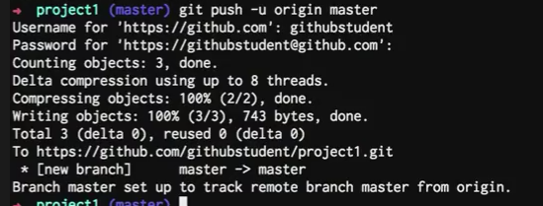

Check out github.com, student repo and we’ll see first.txt is shown. (26:05)

Join and participate an existing project

Githubtrainer/hellogitworld

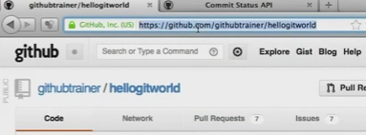

Copy the URL and send to student

Student (while logged in to github web) paste the URL to address and browses to the hellogitworld project.

Student has read-only access.

So, student needs to “**fork**” hellogitworld

To get working.

Copy the repo address from student account.

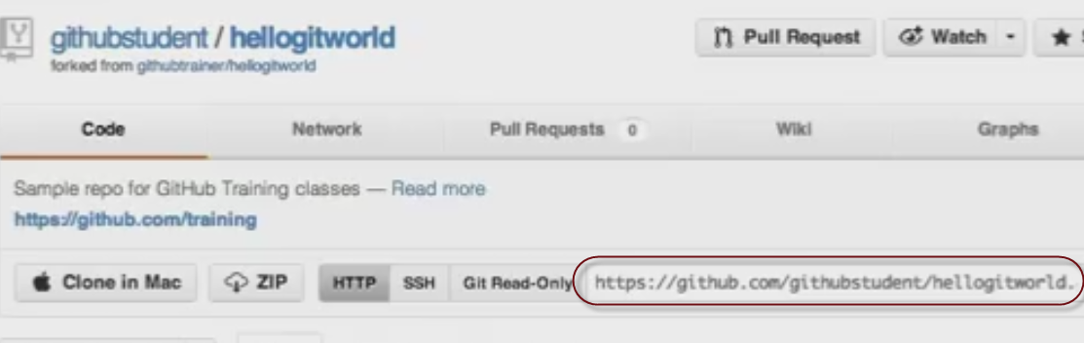

And then, in command line, be in student account, as a student issue this command (28:49):

(get out of project1: cd ..)

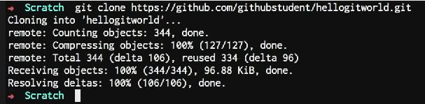

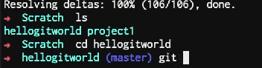

Everything including branches copied to local repo. We can see the branch names (29:30):

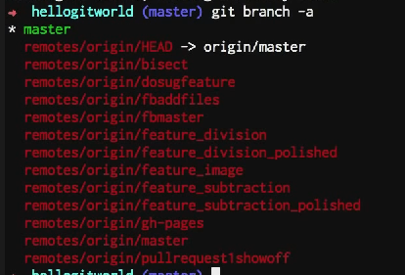

Create a new branch:



Now, switch to the new branch (toggle to branch novclassfeature) using checkout (29:56):



At this point there is no difference between master branch and the newly created branch.

Create a new text file on the new branch novclassfeature and save:

Notepad text2.txt

Next, git status, git add text.txt, git commit –m “second commit”

Next, publish the new branch to github student account (33:00):

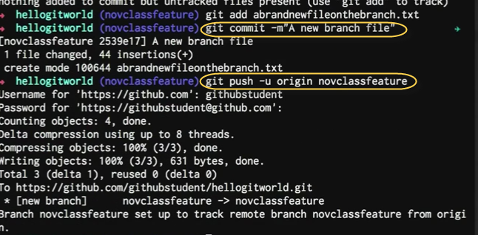

Listen again from 33:38: Switching to ‘master’ branch shows the new file is not there.

On Github account, offer the changes (the new branch file) to be included to the original project through a “Pull Request” (35:14):

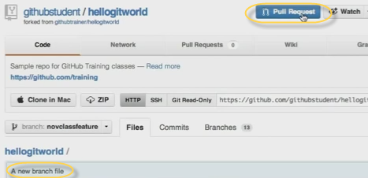

Clicking on “**Pull Request**” (on Github web) shows this (35:28):

Why it is “pull request” (and not “push request”)? (36:10): because my changes are not pulled in it to the “official” copy. The admin “pulls” them in to the official branch. In comments, type the justification (what my changes are offering) why the changes should be pulled by the admin.

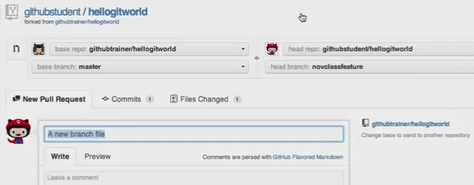

At the end, send the Pull request (green button at the bottom).

Now, back to “trainer” github account and click on Pull Requests (37:25) to see list of requests:

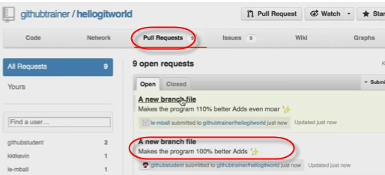

To accept the request the teacher can click on “Merge pull request” and after checking click on “Confirm Merge” (38:10).

Now the changes are in the core of the project.

**On Windows for GitHub app**:

from 42:40 minute